Experiment No: 1
Date: 16-7-2008

FAMILIARIZATION OF COMPONENTS
AIM
To familiarize the given components
- DC power supply
- Multimeter
- Function Generator
- Cathode Ray Oscilloscope
- Bread board

COMPONENTS REQUIRED

1. DC power supply
- Multimeter
- Function Generator
- Cathode Ray Oscilloscope
- Resistor
- Capacitor
- Diode
- Bread board

THEORETICAL BACKGROUND

DC POWER SUPPLY
The DC power supply is the most common source of power supply required for the proper working of electronic devices such as diodes, zener diodes, transistors, FETs, SCRs, BJTs, vacuum tubes, etc. The DC power supply does not vary in the output. This is mainly due to the variation of the load and also because of the variation of AC input to the source of the DC supply. This kind of supplied load is known as Regulated power supply.
Active components need the application of DC supply on the electrodes or terminals. The emitter circuit of a bipolar junction transistor needs forward bias; the collector of the same component needs reverse bias DC, the anodes of the vacuum tubes use high voltage positive DC potential, the control guides need a negative potential etc. The blockwise placement of the components can be studied by knowing the functioning of the circuit. The transformer used is a step-down transformer used for a low voltage output, but a step-up transformer is used if the output required is high. The transformer is used to provide the require magnitude of the DC output voltage. A rectifier circuit consisting of diodes which converts the output of the transformer circuit into a pulsating DC consists of both AC components with a ripple factor of 0.48 for full wave rectifier output. The AC Components should be eliminated. The filter circuit helps to smoothen the output by minimizing the ripples in the supply. Capacitors and inductors are used in filter circuits.

MULTIMETER
A multimeter is used to measure many electrical quantities. It can measure voltages (AC
and DC), currents (AC and DC0 and resistances. A multimeter is a voltmeter, milliammeter and ohmmeter combined together. It has various ranges of voltage, current and resistance measurements.
A multimeter may also be used in diode testing and also in continuity tests.

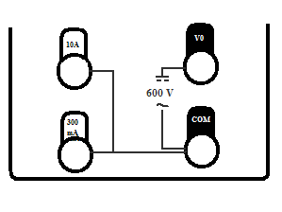
Input Jack
Volts, Ohms, Diode test

Amps

Milliamps

The black lead of the multimeter is always plugged into the common terminal. The red lead of the multimeter is plugged into the 10 Amps jack when currents greater than 300 Milliamps are to be measured. The red lead is plugged into the 300 Milliamps jack when measuring a current less than 300 Milliamps and the remaining jack is used for the measurement of voltage or resistance.

FUNCTION GENERATOR
Function generator is a piece of electronic test equipment used to generate electrical waveforms. These waveforms can be either repetitive, or single-shot in which case some kind of triggering source is required.
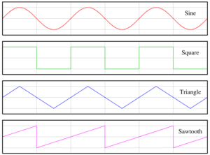

The resulting waveforms can be injected into a device under test and analyzed as they progress through the device, confirming operation of the device.

POWER: Push button switch for supplying power to instrument.
- DIGITAL DISPLAY (7- SEGMENT LED): 4- digit frequency/ amplitude meter. LED indicators for Hz, kHz, mV and V

- FREQ/AMP: Selects display of frequency or amplitude.
- AMP(Adjusting knob): Continuous adjustment of the output amplitude from 0 to -20dB when terminated with 50Ω.
- -20 dB, 20 dB (Push button): Two fixed attenuators, -20 dB each. They can e activated to give a total attenuation of 4_0 dB results. Including the amplitude control 4 the maximum attenuation amounts to -60 dB.
- OUTPUT (BNC connectors): Short circuit proof signal output of the generator. The output impedance is 50Ω switch selectable. Maximum output amplitude is 30 V_{pp}.50 Ω/ 600 Ω: Push button when pressed selects 600 Ω else 50 Ω in released position.
- FUNCTION (4 position push buttons switch): Mode selection DC- Sine- Triangle- Square.
- DC (on), OFFSET (Adjusting knob): Adjustment of the positive or negative offset voltage. This DC voltage can be superimposed on the output signal. The maximum offset voltage is ± 15 V or ± 7.5 V when terminated with 50 Ω.
- OVERDRIVE: When working in the offset mode, the output amplifier is overdriven either in positive or in negative direction, the corresponding LED lit up. FVAR (Adjusting knob): Continuous and linear frequency adjustment from 1 Hz to 1 MHz in steps, selected with frequency range.
- FREQUENCY (7 position push button switch): Frequency coarse adjustment from 1 Hz to 1 MHz in 7 decade steps.
- VAR: When trigger output is selected in CMOS, output can be set with var.
- TRIG OUTPUT (BNC connectors): This short circuit proof output supplies a square signal in synchronous with output signal.
- TTL/ CMOS: Switch selects trigger output TTL or CMOS.
- FM IN (BNC connectors): Applying a DC voltage to this input will vary the oscillator frequency linearly to maximum of 1:100.
- AMPL (Adjusting knob): Attenuation of input voltage for FM input. This permits the user to change the sweep width.

CRO (Cathode Ray Oscilloscope)

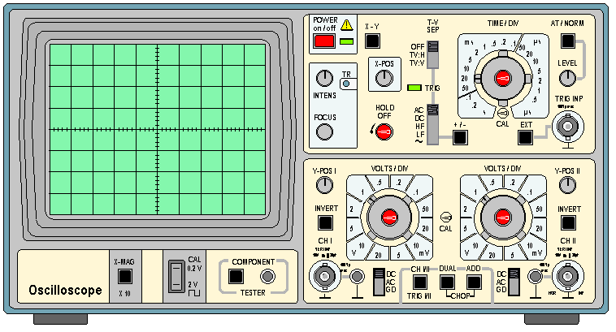

An oscilloscope is easily the most useful instrument available for testing circuits because it allows you to see the signals at different points in the circuit. The best way
of investigating an electronic system is to monitor signals at the input and output of each system block, checking that each block is operating as expected and is correctly linked to the next.

- POWER: Push button switch for supplying power to the instrument.
- X5: Switch when pushed inwards gives 5 times magnification of the X signal.
- XY: Switch when pressed cuts off the time base and allows access the external horizontal signal to be fed through CH II.
- CH-I/ CH-II/ TRIG I/ TRIG II: Switch when out selects and triggers CH-I and when pressed selects and triggers CH-II.
- MONO/ DUAL: Switch selects the dual operation.
- ALT/ CHOP/ ADD: Switch selects alternate or chopped in DUAL mode.
- TRIG. INP: Socket provided to feed external trigger signal in EXT mode.
- CALOUT: Socket provided for square wave output 200mV, used for probe compensation and checking vertical sensitivity.
- HOLDOFF: Controls hold off time between sweeps Normal position = full ccw.
- X – POS: Controls horizontal position of trace.
- EXT: Switch when pressed allows external triggering signal to be fed from socket marking TRIG INP.
- VAR: Controls the time speed in between 2 steps of TIME/ DIV switch. For calibration put this fully anticlockwise.
- LINE: Switch when pressed displayed signal gets synchronized with mains/ line frequency.
- ALT: Selects alternate trigger mode from CH - I and CH – II.
- +/-: Switch selects the slope of triggering, whether positive going or negative going. INV CH - II: Switch when pressed inverts the CH – II.
- INTENS: Controls the brightness of the trace.
- TR: Controls the alignment of the trace with graticule.
- CT: Switch when pressed starts CT operation.
- DC/ AC/ GD: Input coupling switch for each channel. In AC the signal is coupled through 0.1 MFD capacitor.
- CH - I(Y) & CH – II(X): BNC connectors serve as input connection for CH – I and CH – II. Channel II input connector also serves as horizontal external signal.
- CT – IN: To test any components in the CT mode, put one test probe in this socket and connect the other test probe in ground.
- VOLTS/ DIV: Switches select the sensitivity of each channel.
- Y POS I & II: Controls provided for vertical deflection of trace for each channel.

In order to prevent damage to the CRO it is necessary to avoid the use of extreme brightness for prolonged periods otherwise the phosphor on the tube face may be Permanently burned. Therefore it is wise to reduce the intensity when not using the CRO for prolonged periods.

COMPONENTS

RESISTORS
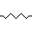
Resistors are passive components which restricts the flow of current. The flow of current through any material encounters an opposing force called resistance. It is measured in ohms, for which the symbol is Ω. It causes a voltage drop between the two terminals. The circuit symbol is shown below.

The resistance R is given by the formula,
R= V/I
The important characters of a resistor are its resistance value, power dissipation
frequency characteristics, s Resistors are mainly of two types- fixed and variable.

FIXED RESISTORS
Some resistors are cylindrical, with the actual resistive material in the centre (composition resistors, now obsolete) or on the surface of the cylinder (film) resistors, and a conducting metal lead projecting along the axis of the cylinder at each end(axial lead). There are carbon film and metal film resistors. The photo above right shows a row of common resistors. Power resistors come in larger packages designed to dissipate heat efficiently. At high power levels, resistors tend to be wire wound types. Resistors used in computers and other devices are typically much smaller, often in surface-mount packages without wire leads. Resistors can also be built into integrated circuits as part of the fabrication process, using the semiconductor material as a resistor. But resistors made in this way are difficult to fabricate and may take up a lot of valuable chip area, so IC designers alternatively use a transistor-transistor or resistor-transistor configuration to simulate the resistor they require.

VARIABLE RESISTORS
The variable resistor is a resistor whose value can be adjusted by turning a shaft or sliding a control. They are also called potentiometers or rheostats and allow the resistance of the device to be altered by hand. The term rheostat is usually reserved for higher-powered devices, above about ½ watt. Variable resistors can be inexpensive single-turn types or multi-turn types with a helical element. Some variable resistors can be fitted with a mechanical display to count the turns. Variable resistors can sometimes be unreliable, because the wire or metal can corrode or wear.

COLOUR CODING IN RESISTORS
Four-band identification is the most commonly used color coding scheme on all resistors. It consists of four colored bands that are painted around the body of the resistor. The scheme is simple: The first two numbers are the first two significant digits of the resistance value, the third is a multiplier, and the fourth is the tolerance of the value. The tolerance for a 4-band resistor will be 2%, 5%, or 10%.

COLOUR CODING
COLOR 1ST BAND 2ND BAND 3RD BAND 4TH BAND
BLACK 0 0 10⁰
BROWN 1 1 10¹ ±1% (F)
RED 2 2 10² ±2% (G)
ORANGE 3 3 10³
YELLOW 4 4 10⁴
GREEN 5 5 10⁵ ±0.5% (D)
BLUE 6 6 10⁶ ±0.25% (C)
VIOLET 7 7 10⁷ ±0.1% (B)
GREY 8 8 10⁸ ±0.05% (A)
WHITE 9 9 10⁹
GOLD 0.1 ±5% (J)
SILVER 0.01 ±10% (K)
NONE ±20% (M)

CAPACITORS
A capacitor is an electrical device that can store energy in the electric field between a pair of closely spaced conductors (called 'plates'). When current is passed through the capacitor, electric charges of equal magnitude, but opposite sign, build up on each plate.
Capacitors are used in electrical circuits as energy-storage devices. They can also be used
to differentiate between high-frequency and low-frequency signals and this makes them useful in electronic filters
A capacitor consists of two conductive electrodes, or plates, separated by an insulator. (The insulator inside a capacitor is sometimes called the dielectric). When the capacitor is in its minimum-energy state, each plate contains equal amounts of electrons and protons and is therefore, overall, electrically neutral. When an electric field is applied across the terminals by an external circuit, excess electrons are forced into one plate, giving it a net negative charge, and some are pulled out of the other plate, giving it a net positive charge. The net charge on the capacitor, even when it is energised, remains zero. The number of electrons added to one plate is equal to the number removed from the other. Even though one plate is now electrically positive, and the other plate is electrically negative, the capacitor as a whole remains electrically neutral. (This fact is named Kirchhoff's current law).
Because of the electric field between the two plates of an energised capacitor, the electrons in the negative plate are attracted towards the positive plate. Since the electrons cannot cross the dielectric, their concentration is highest on the side of the negative plate facing the gap. Conversely, the electrons in the positive plate are repelled from the negative plate by the electric field. Their concentration is lowest on the side of the positive plate nearest the gap. The protons in both plates are fixed in position by the atomic structure of the material.
The capacitor's capacitance (C) is a measure of the amount of charge (Q) stored on each plate for a given potential difference or voltage (V) which appears between the plates:
C=Q/V
In SI units, a capacitor has a capacitance of one farad when one coulomb of charge causes a potential difference of one volt across the plates. Since the farad is a very large unit, values of capacitors are usually expressed in microfarads (µF), nanofarads (nF) or picofarads (pF).

DIODES
Diodes allow electricity to flow in only one direction. The arrow of the circuit symbol shows the direction in which the current can flow. Diodes are the electrical version of a valve and early diodes were actually called valves.

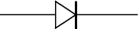

FORWARD VOLTAGE DROP
Electricity uses up a little energy pushing its way through the diode, rather like a person pushing through a door with a spring. This means that there is a small voltage across a conducting diode, it is called the forward voltage drop and is about 0.7V for all normal diodes which are made from silicon. The forward voltage drop of a diode is almost constant whatever the current passing through the diode so they have a very steep characteristic (current-voltage graph).

REVERSE VOLTAGE DROP
When a reverse voltage is applied a perfect diode does not conduct, but all real diodes leak a very tiny current of a few µA or less. This can be ignored in most circuits because it will be very much smaller than the current flowing in the forward direction. However, all diodes have a maximum reverse voltage (usually 50V or more) and if this is exceeded the diode will fail and pass a large current in the reverse direction, this is called breakdown.

BREAD BOARD
A solderless bread board is a multipurpose board with 128 groups and 5 connected terminals. In each we can insert a pin of the components. The inserted components are caught between two plates with spring action. The 128 groups of terminals are arranged on the upper and lower side of the bread board in two sets of 64 each. Each group on both sides marked with 1-62 except the first two groups. It means that the numbering starts from the third group and the first two groups are not numbered.

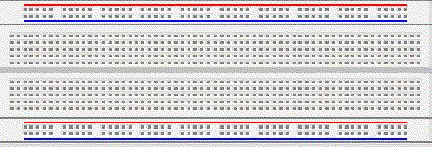

PROCEDURE
The following components were analyzed
1. DC power supply
2. Multimeter
- Function Generator
- Cathode Ray Oscilloscope
- Bread board

APPLICATIONS
Active components need the application of dc on various electrode or terminals. The anode of the vacuum tubes use high voltage positive dc potential, the control guides need a negative potential. Biasing is involved in zener diodes, FET’s, SCR’s, UJT’s, gas tubes etc.
Multimeter is used to measure many electrical quantities.
Function generator can be used to generate multiple waveforms.
The cathode-ray oscilloscope is one of the most widely used test instruments; its commercial, engineering, and scientific applications include acoustic research, television-production engineering, and electronics design. It is also used in electrochemical measurement as a recording device connected to a polo graph with a high potential sweep rate. One of the most frequent uses of scopes is in trouble shooting malfunctioning electronic equipment.
In integrated circuits special resistors are used. In power hybrid applications a high a voltage resistor can be used as current sensor.

RESULT
The various components and instruments used in Electronics lab were familiarized.

Experiment No: 2
Date: 23-7-2008

DIODE CHARACTERISTICS
AIM
To study and plot:
- The forward characteristics of Silicon diode.
- The reverse characteristics of Zener diode.

COMPONENTS REQUIRED

COMPONENTS | QUANTITY
1N4001 (Silicon diode) | 1
SZ 6.8 (Zener diode)  OA79(Germanium Diode) | 1  1
Resistor – 100Ω | 1
Ammeter – 0-10mA | 1
Ammeter – 0-100mA | 1
Voltmeter – 0-1V | 1
Voltmeter – 0-10V | 1
Rheostat - 330 Ω/1.1A | 1
Power supply – 0-30V Dual | 1
Bread board | 1

THEORY
A Diode is an electrical device allowing current to move through it in one direction with far greater ease than in the other. The p-n junction diode is obtained by joining a piece of p-type and n-type material such that the crystal structure remains continuous at the boundary. When the two layers are joined together, the electrons in the N region are attracted by the relatively positive holes in the P region. Due to this, both the charge carriers approach the junction and recombine (the fact is that hole is an electron-deficient position). Due to this, there is neutralization of majority carriers at the junction, forming the depletion layer. So, that region is depleted of charges and acts as an insulator.
But the depletion region can’t grow without limit. As the layer widens, the insulating properties becomes so prominent that the attractive movement of the charge carriers is overpowered by the insulation and the flow of charge carriers goes down. So, due to the accumulation of charge carriers, a potential is developed across the junction and this potential is called barrier potential. For silicon diodes, it is about 0.6V.
If an external voltage is given such that its potential is equal to the barrier potential (0.6V), and the positive pole is connected to the P region and negative pole to N region, there won’t be any considerable flow of current across the junction. This is since the whole applied voltage is dropped across the depletion layer and nothing is left to energize the charge carriers. But if the voltage is increased further, the depletion layer’s insulation becomes ineffective compared to the repulsive force of the external voltage source’s poles. So, the charge carriers are energized and they begin to move across the junction. Then the diode is said to be in ‘forward bias’.

A Zener diode is also a silicon diode, except for the fact that it is heavily doped. So, it works like a normal diode in the forward region, but can withstand much heavier currents in the reverse region, beyond the breakdown voltage called ‘Zener knee voltage’.
Just like other diodes, the Zener also can drop a voltage of 0.6V in the forward region. But for other diodes, in the reverse bias condition, if the voltage exceeds the breakdown voltage, the current in the circuit becomes very high. If there are no limiting resistors, the diode will be damaged permanently. Valence electrons which break free under the influence of the applied electric field can be accelerated enough that they can knock loose other electrons and the subsequent collisions quickly become an avalanche. When this process is taking place, very small changes in voltage can cause very large changes in current. The Zener is designed to withstand just that. The breakdown process depends upon the applied electric field, so by changing the thickness of the layer to which the voltage is applied, Zener diodes can be formed which break down at voltages from about 4 volts to several hundred volts.
Zener diode is designed to have a greatly reduced breakdown voltage and heavy doping levels. Due to heavy doping, electrons can tunnel from the valence band of the P-type material to the conduction band of the N-type material.

The Zener Diode is used as a voltage regulator. (In breakdown, even if current varies considerably, the voltage remains almost constant)

PROCEDURE

- Identify the anode and cathode of the diode using multimeter, set up the circuit on the bread board as in diagram.
- Switch on the power supplies and vary the rheostat so that the voltmeter readings vary from 0 to 1V in steps of 0.1V. Note down the readings of voltmeter and ammeter for each setting of rheostat. Tabulate the readings and plot the graph for the forward bias condition. Reverse characteristics of Si diode can’t be measured practically. It is in nanoamperes.
- Repeat step (2) using Ge diode. Plot forward characteristics.
- For Zener reverse characteristics, connect the diode according to the circuit. Vary the rheostat and note the ammeter and voltmeter readings. Plot the graph and find the Zener breakdown voltage.

CIRCUIT DIAGRAMS
Si diode forward characteristics.
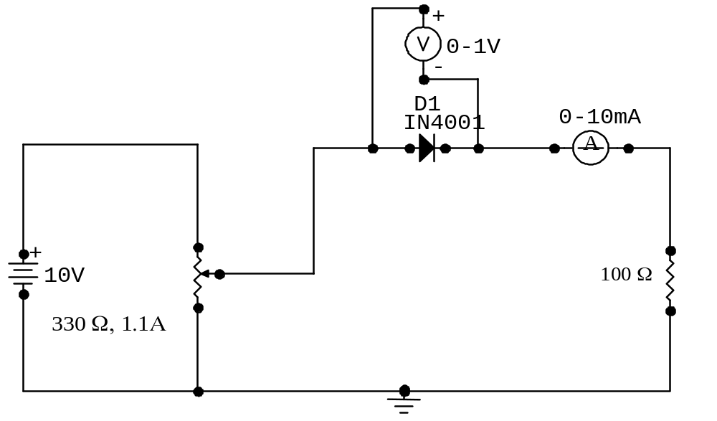

Ge Diode forward characteristics.
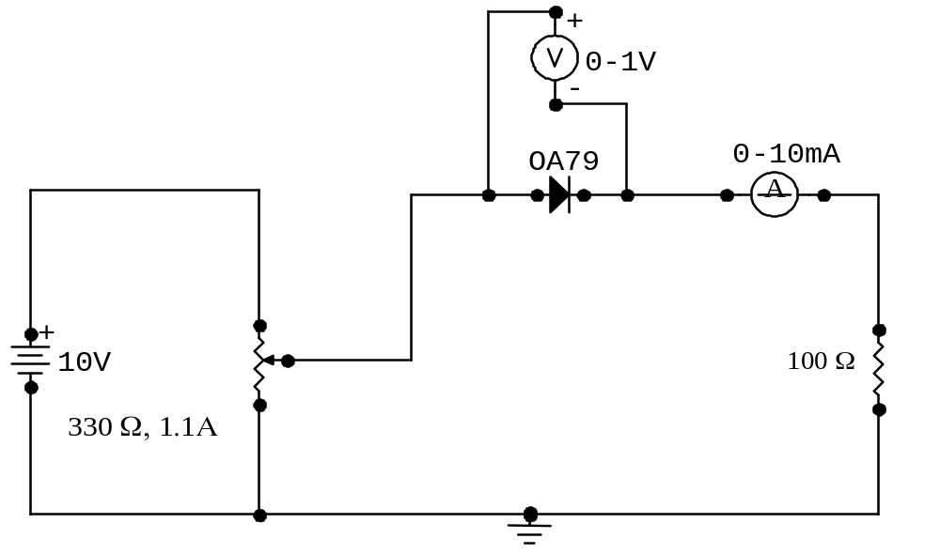

Zener diode reverse characteristics.
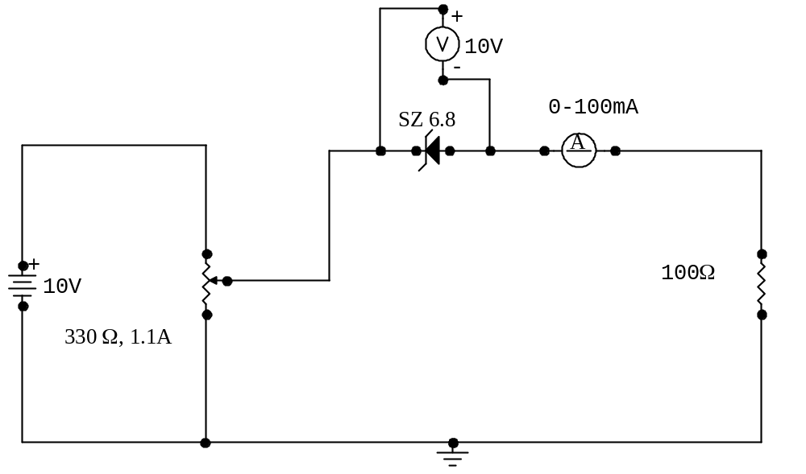

OBSERVATION TABLES
Forward characteristics of Si diode.

V(volts) | I(mA)
0.1 | 0
0.2 | 0.25
0.5 | 1.0
0.56 | 2.0
0.59 | 3.0
0.63 | 6.0
0.64 | 8.4
0.65 | 10

Forward characteristics of Ge Diode

V(volts) | I(mA)
0.02 | 0
0.14 | 0.3
0.2 | 0.6
0.26 | 0.9
0.32 | 1.3
0.4 | 1.9
0.6 | 3.6
0.8 | 5.6
1 | 8.0

Reverse characteristics of Zener diode.

V(volts) | I(mA)
1 | 0.1
2 | 0.3
3 | 0.5
4 | 0.6
5 | 0.7
6 | 0.9
6.6 | 1.1
6.7 | 10

CALCULATIONS

Si Diode forward biased at 0.59 V
Static Resistance = V/I = 0.62 . = 124Ω
5x10⁻³

Dynamic Resistance=ΔV/ΔI = 0.62-0.55 . = 23Ω
(5-2)x10⁻³

Ge Diode forward biased at .4V
Static Resistance = V/I = 0.4 . = 210.53Ω
1.9x10⁻³

Dynamic Resistance=ΔV/ΔI = 0.6-0.4 . = 117.65Ω
(3.6-1.9)x10⁻³

Zener Diode break down voltage is 6.7 V

Static Resistance = V/I = 6.7 . = 670Ω
10x10⁻³

Dynamic Resistance=ΔV/ΔI = (6.7-6) . = 11.23Ω
(10-1.1) x10⁻³

RESULT

The forward and reverse characteristics of the given diodes have been studied and plotted.

Silicon diode forward biased = 0.59V
Static resistance = 124Ω
Dynamic resistance = 23Ω

Germanium diode forward biased = 0.4V
Static resistance = 210.53Ω
Dynamic resistance = 117.65Ω

Zener diode reverse biased = 6.7V
Static resistance = 670Ω
Dynamic resistance = 11.23Ω

INFERENCE
Forward characteristics of Silicon and Germanium diode studied.
Reverse characteristics of Zener diode also studied.

Cut in voltage of Germanium diode is less than Silicon diode. Beyond cut in voltage change in current is greater for a small change of voltage.

Beyond breakdown point voltage across Zener diode remains constant for large variations of current.

Experiment No :3
Date: 30-7-2008

HALF WAVE RECTIFIER

AIM
To study and plot the output waveforms of Half Wave Rectifier
- Without filter.
- With filter – 100μF capacitor and 470μF capacitor.
and find out the ripple factor in each case.

THEORETICAL BACKGROUND
Α rectifier is used to convert an alternating signal to its corresponding unidirectional equivalent. One such rectifier is the half wave rectifier. This rectifier uses the properties of a diode (usually silicon diode) to perform its rectification operation. A diode conducts completely when forward biased and when reverse biased, it doesn’t conduct at all (till it reaches breakdown, when the diode is damaged). An alternating waveform has 2 half cycles-one positive and one negative. Based on the alignment, the bias the diode. Let the diode be aligned in such a way that it is forward biased for positive half cycles of the input signal. Now, the signal is input. When the diode encounters a positive half cycle, it lets the signal through giving an identical output. After that half cycle, a negative half cycle comes. Then the diode is reverse biased and it cuts off that part of the signal. So, in the output, we get no negative half cycles (if the diode is placed the other way around, the output will be just the opposite. We get no positive half cycles). This rectifier is called half wave since in the output we get only half the input given to the system.

So, the output obtained is unidirectional, ie, it goes to only one direction. But still it is pulsating. This pulsating behavior is denoted by the wave’s ripple factor. The ripple factor gives the linearity and purity of the signal. Lesser the ripple factor, the more linear the signal. To reduce the ripple factor, we use capacitor filters. It works as follows (here we consider the input and output as voltage signals).

When the voltage rises, the capacitor gets charged, ie, it is storing charges. When the voltage reaches its peak, the capacitor gets charged to its maximum. Then the voltage begins to fall (as a part of its pulsating nature). But the capacitor is still charged. So, by Lenz’s law, it tries to oppose this fall by acting as a voltage source, discharging all the time (due to charge accumulation, it forms a set of oppositely charged plates, enough to generate a potential). But, due to discharging, the potential falls, but gradually. This potential is also obtained in the output. Due to the combined effect, we get the impression that the signal itself is falling slowly and we get an output with lesser pulses. So, the ripple factor goes down. When the capacitance increases, the amount of charge stored also increases. Consequently, the time taken for discharge also increases. As a result, we get a more linear output and the ripple factor decreases further.

COMPONENTS REQUIRED

COMPONENTS | SPECIFICATIONS
Resistor | 100Ω, 1/2 W
Diode | 1N 4007, I_{f} =1A
Capacitor | 100μF, 35V; 470μF, 35V
Step down transformer | 230V/6-0-6
Bread board
CRO | 25 MHz, APLAB dual trace
Connecting wire

CIRCUIT DIAGRAM

Without filter
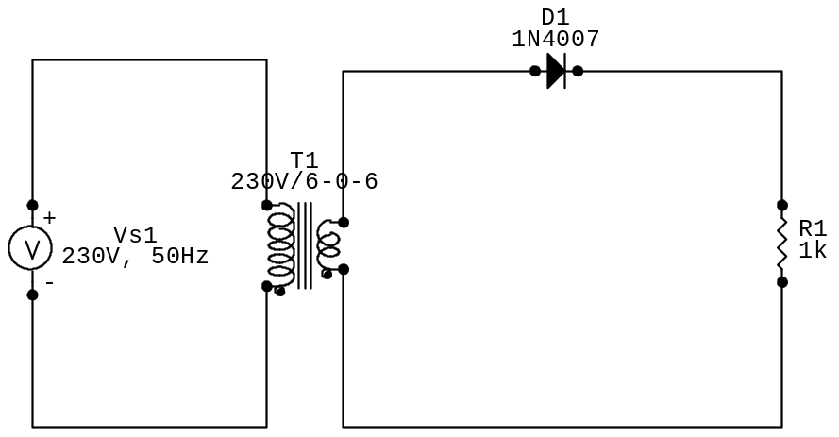

With filter
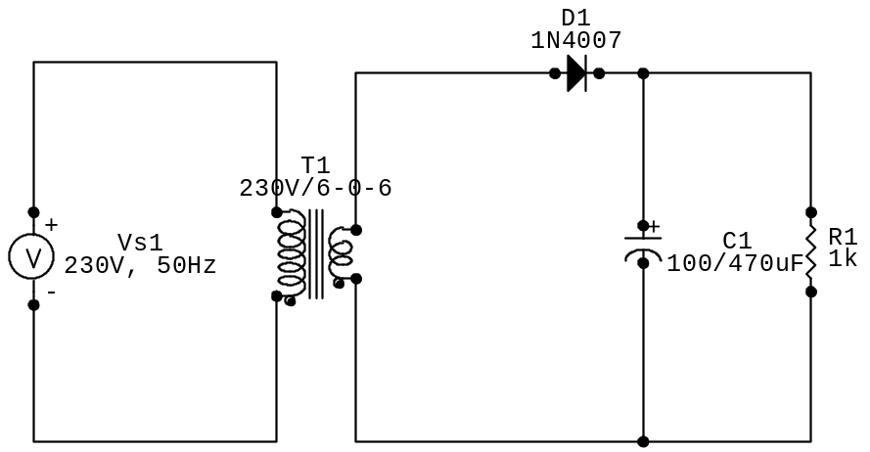

PROCEDURE

- The circuit for Half Wave Rectifier is wired as in the circuit diagram and main supply is switched on.
- Transformer’s secondary (output) voltage waveform and the output voltage waveform from the load resistor are observed simultaneously on the CRO and peak value is noted.
- V_{m} is noted from the CRO. The process is repeated with both capacitors.
- Ripple factor is calculated from the formula.

OBSERVATION

Without filter
V_{m} = 8.5V

With 100μF filter
V_{rp-p} = 1V

With 470μF filter
V_{rp-p} = 0.398V

CALCULATIONS

Without filter
V_{m} = 8.5V
V_{rms} = V_{m}/2
= 8.5/2
= 4.25V
V_{dc} = V_{m}/π
= 8.5/π
= 2.546V

Ripple factor, γ = √(( V_{rms}/ V_{dc})²-1)
= √(( 4.25/2.546)²-1)
= 1.337

With 47μF filter
V_{rp-p} = 2.6V
V_{rms} = V_{rp-p}/2√3
= 2.6 /2√3
= 0.7505V
V_{dc} = V_{m}-(V_{rp-p}/2)
= 8.5-(2.6/2)
= 7.2V
Ripple factor, γ = V_{rms}/ V_{dc}
=0.7505/7.2
= 0.104
Theoretically, γ = V_{rms}/ V_{dc} = 1/(2√3fCR_{L})
=1/(2√3x50x47x1000x10⁻⁶)
= 0.12
With 100μF filter
V_{rp-p} = 1V
V_{rms} = V_{rp-p}/2√3
= 1/2√3
= 0.2886V
V_{dc} = V_{m}-(V_{rp-p}/2)
= 8.5-(1/2)
= 8V
Ripple factor, γ = V_{rms}/ V_{dc}
= 0.2886/8
= 0.036
Theoretically, γ = V_{rms}/ V_{dc} = 1/(2√3fCR_{L})
=1/(2√3x50x100x1000x10⁻⁶)
= 0.0577
With 470μF filter
V_{rp-p} = 0.398V
V_{rms} = V_{rp-p}/2√3
= 0.398/2√3
= 0.115V
V_{dc} = V_{m}-(V_{rp-p}/2)
= 8.5-(0.398/2)
= 8.3V
Ripple factor, γ = V_{rms}/ V_{dc}
= 0.115/8.3
= 0.013
Theoretically, γ = V_{rms}/ V_{dc} = 1/(2√3fCR_{L})
=1/(2√3x50x470x1000x10⁻⁶)
= 0.012

RESULT

The output waveforms of Half Wave Rectifier was plotted and studied.
Ripple factor without filter = 1.212

Ripple factor with 47μF filter = 0.104
Theoretical =0.12

Ripple factor with 100μF filter = 0.064
Theoretical = 0.057

Ripple factor with 470μF filter = 0.012
Theoretical = 0.012

Experiment No :4
Date: 30-7-2008

FULL WAVE RECTIFIER

AIM
To study and plot the output waveforms of
- Center tapped full wave rectifier
- Bridge rectifier
under two conditions:
- Without filter.
- With filter – 100μF capacitor and 470μF capacitor.
and find out the ripple factor in each case.

THEORETICAL BACKGROUND
The Full-Wave rectifier uses the properties of a diode (usually silicon diode) to perform its rectification operation. A diode conducts completely when forward biased and when reverse biased, it doesn’t conduct at all (till it reaches breakdown, when the diode is damaged). An alternating waveform has 2 half cycles-one positive and one negative. Based on the alignment, the bias the diode. Let the diode be aligned in such a way that it is forward biased for positive half cycles of the input signal. Now, the signal is input. When the diode encounters a positive half cycle, it lets the signal through giving an identical output. After that half cycle, a negative half cycle comes. Then the diode is reverse biased and it cuts off that part of the signal. So, in the output, we get no negative half cycles (if the diode is placed the other way around, the output will be just the opposite. We get no positive half cycles).
Now, the full wave rectifier has 2 diodes facing the same way, given across the centre tap and the supply wires. When the output is obtained across the secondary of the transformer, it is split into 2 parallel circuits by the centre tap, each differing the other by a 180º phase shift. So, the inputs to the diodes also differ by 180º. ie, when one diode has a positive input, the other has a negative input. So, at one time, one diode is forward biased while the other is reverse biased. This alternates as time progresses. Due to this, every half cycle of input, irrespective of positivity or negativity will have a positive (or negative, depending on diode alignment) half cycle at the output. Since no half cycle is lost, this rectifier is called a full wave rectifier.
In the case of bridge rectifiers, the circuit is arranged in such a way that a set of 2 opposite diodes conduct at a time. When the input is given, the circuit behaves such that it is a half wave rectifier. The diode combination changes as the cycle changes. For the negative half cycle of input, the bridge network also automatically reverses the polarity so that the output is a positive half cycle. Thus, with 2 half wave rectifiers working alternately, the bridge network forms a full wave rectifier.
Now, the output obtained is unidirectional, ie, it goes to only one direction. But still it is pulsating. This pulsating behavior is denoted by the wave’s ripple factor. The ripple factor gives the linearity and purity of the signal. Lesser the ripple factor, the more linear the signal. To reduce the ripple factor, we use capacitor filters. It works as follows (here we consider the input and output as voltage signals).
When the voltage rises, the capacitor gets charged, ie, it is storing charges. When the voltage reaches its peak, the capacitor gets charged to its maximum. Then the voltage begins to fall (as a part of its pulsating nature). But the capacitor is still charged. So, by Lenz’s law, it tries to oppose this fall by acting as a voltage source, discharging all the time (due to charge accumulation, it forms a set of oppositely charged plates, enough to generate a potential). But, due to discharging, the potential falls, but gradually. This potential is also obtained in the output. Due to the combined effect, we get the impression that the signal itself is falling slowly and we get an output with lesser pulses. So, the ripple factor goes down. When the capacitance increases, the amount of charge stored also increases. Consequently, the time taken for discharge also increases. As a result, we get a more linear output and the ripple factor decreases further.
Here, the linearity of the output will be higher (ie, lesser ripple factor) in all the cases since the signals are much more immediate. The time between the peaks of the signals is 10ms here, instead of 20ms for Half Wave Rectifier. So, the capacitor gets recharged much quicker and doesn’t lose as much charge as in the case of Half Wave Rectifier. So, the dip in voltage is less here and the smoothness of the waves increase.

COMPONENTS REQUIRED

COMPONENTS | SPECIFICATIONS
Resistor | 100Ω, 1/2 W
Diode | 1N 4007, I_{f} =1A
Capacitor | 100μF, 35V; 470μF, 35V
Step down transformer | 230V/6-0-6
Bread board
CRO | 25 MHz, APLAB dual trace
Connecting wire

CIRCUIT DIAGRAM
Centre tapped Full Wave Rectifier without filter

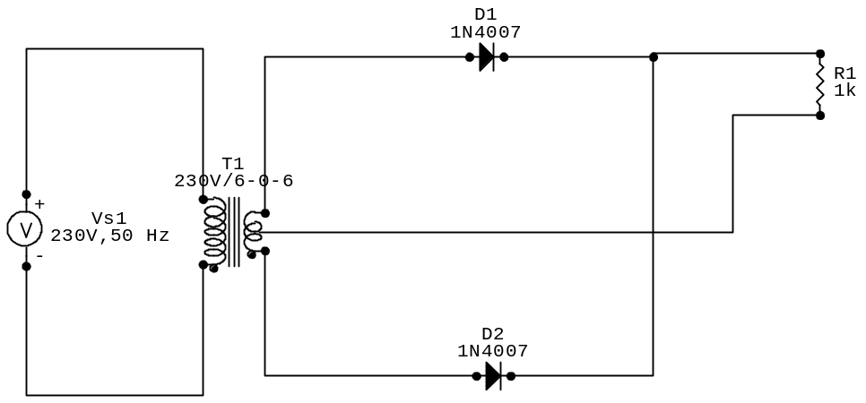

Centre tapped Full Wave Rectifier with filter
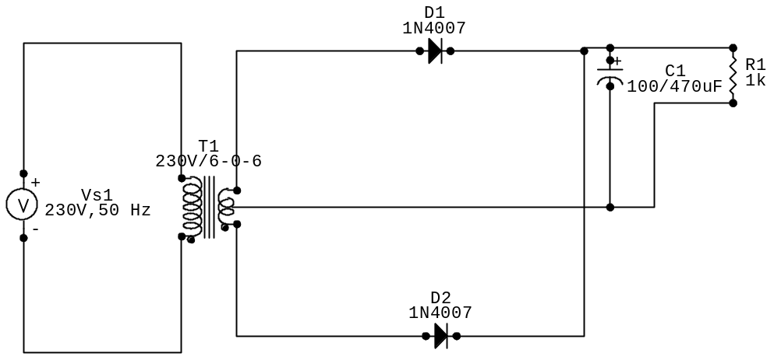

Bridge rectifier without filter
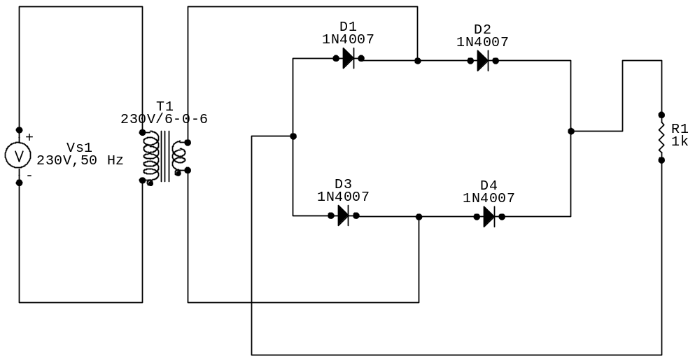

Bridge rectifier with filter

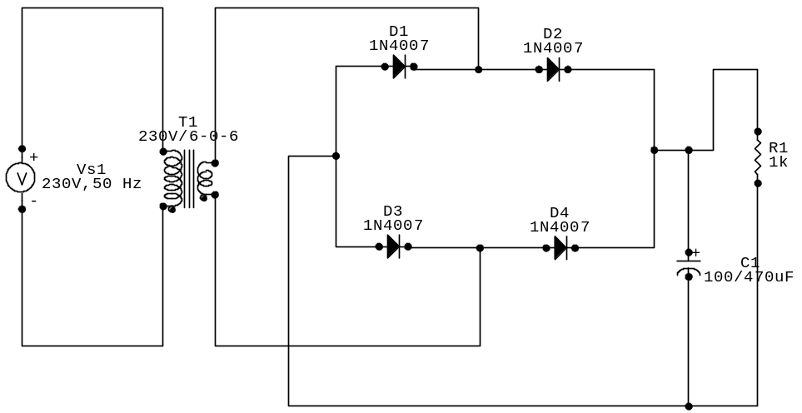

PROCEDURE

For Centre tapped full wave rectifier.
- The circuit is wired as in the circuit diagram and main supply is switched on.
- Transformer’s secondary (output) voltage waveform and the output voltage waveform from the load resistor are observed simultaneously on the CRO and peak value is noted.
- V_{m} is noted from the CRO. The process is repeated with both capacitors.
- Ripple factor is calculated from the formula.

For Bridge rectifier.
- The circuit is wired as in the circuit diagram and main supply is switched on.
- Transformer’s secondary (output) voltage waveform and the output voltage waveform from the load resistor are observed simultaneously on the CRO and peak value is noted.
- V_{m} is noted from the CRO. The process is repeated with both capacitors.
- Ripple factor is calculated from the formula.

OBSERVATION
For Centre tapped full wave rectifier
Without filter; V_{m} = 9V
With 47μF filter; V_{rp-p} = 1.4V
With 100μF filter; V_{rp-p} = 0.6V
With 470μF filter; V_{rp-p} = 0.2V

For Bridge rectifier
Without filter; V_{m} = 9V
With 47μF filter; V_{rp-p} = 1.4V
With 100μF filter; V_{rp-p} = 1.15V
With 470μF filter; V_{rp-p} = 0.4V

CALCULATIONS
Without filter
V_{m} = 9V
V_{rms} = V_{m}/√2
= 9/√2
= 6.34V
V_{dc} = 2V_{m}/π
= 2x9/π
= 5.267V
Ripple factor, γ = √(( V_{rms}/ V_{dc})²-1)
= √(( 6.34/5.267)²-1)
= 0.670
With 47μF filter
V_{rp-p} = 1.4V
V_{rms} = V_{rp-p}/2√3
= 1.4/2√3
= 0.404V
V_{dc} = V_{m}-(V_{rp-p}/2)
= 9-(1.4/2)
= 8.3V
Ripple factor, γ = V_{rms}/ V_{dc}
= 0.404/8.3
= 0.0486
Theoretically, γ = V_{rms}/ V_{dc} = 1/(4√3fCR_{L})
=1/(4√3x50x47x1000x10⁻⁶)
= 0.061
With 100μF filter
V_{rp-p} = 0.6V
V_{rms} = V_{rp-p}/2√3
= 1.15/2√3
= 0.331V
V_{dc} = V_{m}-(V_{rp-p}/2)
= 9-(1.15/2)
= 8.425V
Ripple factor, γ = V_{rms}/ V_{dc}
= 0.331/8.425
= 0.039
Theoretically, γ = V_{rms}/ V_{dc} = 1/(4√3fCR_{L})
=1/(4√3x50x100x1000x10⁻⁶)
= 0.028
With 470μF filter
V_{rp-p} = 0.4V
V_{rms} = V_{rp-p}/2√3
= 0.4/2√3
= 0.115V
V_{dc} = V_{m}-(V_{rp-p}/2)
= 9-(0.4/2)
= 8.8V
Ripple factor, γ = V_{rms}/ V_{dc}
= 0.115/8.8
= 0.0058
Theoretically, γ = V_{rms}/ V_{dc} = 1/(4√3fCR_{L})
=1/(4√3x50x470x1000x10⁻⁶)
= 0.0061
RESULT
The output waveforms of Full Wave Rectifier (Centre tapped and Bridge network) was plotted and studied. In both cases,
Ripple factor without filter = 0.670
Ripple factor with 47μF filter = 0.0486
Theoretical = 0.061
Ripple factor with 100μF filter = 0.039
Theoretical = 0.028
Ripple factor with 470μF filter = 0.0058
Theoretical = 0.0061

EXP NO: 5
DATE: 13/08/2008

CLIPPING

AIM
To design and setup various clipping circuits using diode and to plot their output waveform.

COMPONENTS REQUIRED

SL. NO. | INSTRUMENTS | SPECIFICATIONS | QUANTITY
1 | Diode | IN 4001 | 2
2 | Resistor | 1KΩ | 1
3 | CRO | 20MHz | 1
4 | Function generator | 0-30V dual | 1
5 | Power supply

THEORETICAL BACKGROUND
Clipper is used to clip off a potion of the waveform. They are also known as amplitude limiters. The basic principle of clipping circuits is based on the unidirectional property of diode. During forward biased condition diode acts like a closed switch and during reverse biased condition diode acts like an open switch. Clipping circuits may be as follows:
- Positive clipping circuit: in this type of clipping, only the positive region of the waveform is clipped off. During the positive half cycle, the diode acts as an open switch and no current passes through the load resistance. Hence no waveform is produced i.e. the positive part is clipped off. During negative half cycle, the diode conducts.
- Negative clipping circuit: in this type of circuit the negative part of the waveform is clipped off. During the positive half cycle, the diode conducts and the waveform is obtained. But during the negative half cycle the diode is reverse biased i.e. it does not conduct. So during the negative half cycle the current through the load resistance is zero. So no waveform is produced.
- Biased clipping circuit: in this type of circuit, a DC supply is connected additionally to the present circuits. It will clip the waveforms as needed by us. To do so we have to change the voltage input of the DC supply.
- Trapezoidal clipping: in this type of circuit we connect both positive and negative diode with a DC source. These diodes clip off both the positive and negative part of the waveform. By using the DC source, we can control the amount of clipping so that we get a waveform in the shape of a trapezoid.

CIRCUIT DIAGRAM
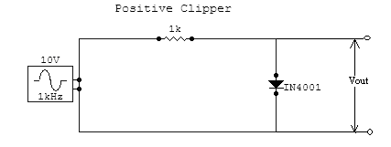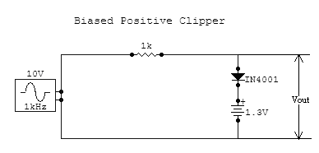

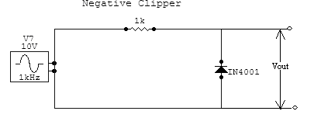

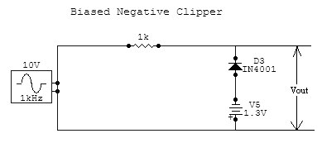
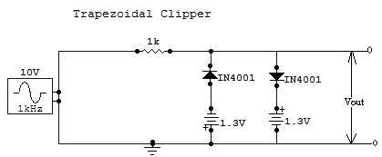

PROCEDURE
- set up the circuit on the bread board after testing each component.
- designed input is given by using a function generator.
- connect the output of the CRO.
- observe the clipped and clamped output waveforms.

RESULT

The clipper circuit was obtained and output waveforms were plotted.

CONCLUSION
By applying an external voltage, the portion of the wave being clipped can be changed. This way, multiple shaped waves can be obtained. The shapes are dependant on the type of bias of the diode and the external voltage applied.

EXP NO: 6
DATE: 28/08/2005

CLAMPING

AIM:
To design and setup and clamping circuits using diode and to plot their output waveform.

COMPONENTS REQUIRED:

SL. NO. | INSTRUMENTS | SPECIFICATIONS | QUANTITY
1 | Diode | IN 4001 | 2
2 | Resistor | 1KΩ | 1
3 | CRO | 20MHz | 1
4 | Function generator | 0-30V dual | 1
5 | Power supply

THEORETICAL BACKGROUND:
CLAMPING:
Here the capacitor is connected in series with the diode. When the input is applied to the circuit, the capacitor gets charged up and the diode connected in series is also forward biased. When the input signal reaches its positive peak value, the capacitor is charged to that peak value. When the signal slowly tends to decrease, the capacitor tends to follow the same charge as that of the input signal but the diode is reverse biased and there is no discharging path for the capacitor. Hence, we say the output remains clamped to the peak of the input signal.
There are two types of clamping circuits. They are,
- Positive clamping: during negative half cycle of the signal, the diode is forward biased and it shorts out the resistor R. The time constant will be about zero because resistance of forward biased diode is zero. Consequently the capacitor charges to positive almost instantly and stays at that level for entire negative half cycle. During the positive half cycle, the signal is V. the diode is forward biased as that the capacitor tries to discharge through the resistor R. applying the Kirchoff’s voltage law, the voltage across R will be 2V. thus the signal is pushed upward by V. So that the negative peak falls to 0 level.
- Negative clipping: during the positive half cycle of the signal, the diode is forward biased and shorts out the resistor R. The time constant will be about 0 because the resistance of the forward biased diode is 0. Hence the capacitor is charged to V volt, and stays at that level to the entire positive half cycle. During the negative half cycle, the signal is V volts. The diode is reverse biased. So the capacitor tries to discharge through R₁. Applying Kirchoff’s voltage law, the voltage across R is -2V. the signal is pushed downward by V volts. So that the peak of positive falls to 0 level.

CIRCUIT DIAGRAM:
POSITIVE CLAMPING AT 0V:
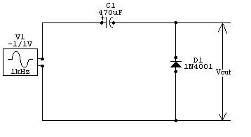
10V

-
POSITIVE CLAMPING AT -3 V:
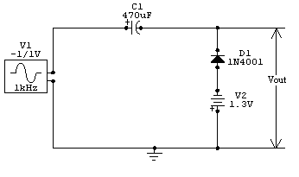
10V

3V
POSITIVE CLAMPING AT 3 V:
10V

3V
NEGATIVE CLAMPING AT OV:
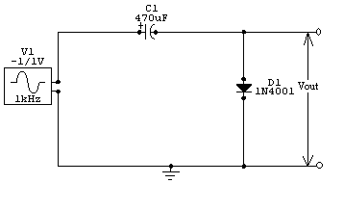
10V

NEGATIVE CLAMPING AT -3V:
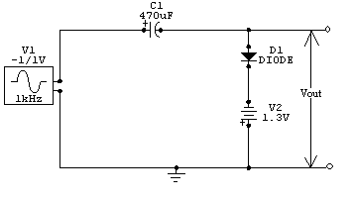
10V
3V
NEGATIVE CLAMPING AT 3V:
10V
3V

PROCEDURE:
- set up the circuit on the bread board after testing each component.
- designed input is given by using a function generator.
- connect the output of the CRO.
- observe the clipped and clamped output waveforms.

RESULT:

The clamper circuit was obtained successfully and output waveforms were plotted.

CONCLUSION:
By applying an external voltage, the vertical shift in the wave can be increased or decreased while the shape of the wave remains in the same form.

EXPT NO: 9
DATE: 8.09.2005

COMMON EMITTER CHARACTERISTICS

INTRODUCTION:
The name CE is because the emitter of the transistor is common to the input and the output circuits. Input signal is applied across the base and emitter and the output is taken across the collector & the emitter. CE configurations is also called grounded emitter configuration.

PROGRAM DEFINITION:
To plot the input and output characteristics of an NPN transistor in common emitter configuration and to calculate various parameters like
- Dynamic input resistance
- Dynamic output resistances &
- current gain (α).

THEORETICAL BACKGROUND:

Transistor can be connected in a circuit in any one of the 3 different configurations, namely, common emitter, common base & common collector. Common emitter (CE)configuration is the most frequently used configuration because it provides voltage, current & power gain more than unity. The name CE is because The emitter of the transistor is common to the input and the output circuits. Input signal is applied across the base and emitter and the output is taken across the collector & the emitter. CE configurations is also called grounded emitter configuration.

Each circuit connection has specific advantages and disadvantages. It may be noted that here that regardless of the circuit connection, the emitter is always biased in the forward direction, while the collector always has a reverse bias.

In CE configuration input is applied between base and emitter and output is taken from the collector and emitter. Here ,emitter of the transistor is common to both input and output circuits & hence the name.

Dynamic input resistance:
Dynamic input resistance can be calculated from the input characteristics curves. It is given by the ratio of small change in the base to emitter voltage to corresponding change in the base current, keeping collector current to emitter voltage constant.IB

ie; ri=∆ VCE /∆ IB keeping VCE constant

Dynamic output resistance:
Dynamic output resistance can be calculated from the output characteristic curves. It is given by the ratio of small change in collector to emitter voltage to corresponding change in collector current, keeping base current constant.

ro = ∆ VBE / ∆ IB keeping IB constant

Common emitter current gain ( β) :It is the ratio of the change in collector current to the corresponding change in base current,keeping the collector to emitter voltage constant.

β =∆ IB /∆ IB keeping VCE constant

Another designation for β is hfe.

Relation between β & α:
The current gain in common Base configuration α is related to
β = α /(1- α) and
α = β/(1+ β).

α is always less than unity. It is evident that as α approaches unity, value of β rises rapidly.
In almost any transistor, less than 5% of the emitter current flows as the base current. Therefore, the value of β is generally greater than 20.uasually, its value ranges from 20 to 500. This type of connection is usually used as it gives appreciable current gain as well as voltage gain.

COMPONENTS REQUIRED:
COMPONENTS | SPECIFICATION | QUANTITY
TRANSISTOR | BC 547 | 1
AMMETER | 0-100µA | 1
VOLTMETER | 1-10MA | 1
 | 0-1V | 1
 | 0-10V | 1
DC VOLTMETER | 0-30V | 1
RHEOSTAT | 1.1A,1.1A | 2
BREAD BOARD |  | 1
MULTIMETER | DIGITAL | 1

PROCEDURE (Input characteristics):
1)Identify the leads of an NPN transistor & test the transistor using a multimeter. Set up the circuit 7 verify the connections using the multimeter.
2)Switch ON the power supplies keeping the rheostat at minimum position. Switch off collector to emitter supply or make it 0V.
3)Note down the base current for different values of base to emitter potential varying it from 0V to 0.7 V or 0.8 V in steps of 0.1 V adjusting the rheostat.
)Repeat step no:3 for different values of collector to emitter voltage (say 3V and 6 V).
5)Draw the characteristic on a graph sheet with VBE on X=axis & IB on Y –axis.
6)Calculate dynamic input resistance taking the ratio of change in VBE to the resulting change in IB at any point, say ,10µA.

PROCEDURE(Output characteristics):

1)Switch ON the power supplies keeping the rheostats at minimum position.
2)Switch OFF input voltage source or reduce it to make In = 0V.Note the value of Ic for different values of VCE from 0-10V in steps of 0.5V.Repeat for other values of base current(say 80 µA -100µA)
3)Fix the base current IB at different value of by adjusting input rheostat. Note the value of IC for different values of VCE from 0-10V in steps of 0.5V.Repeat for another values of base current
4)Plot the output characteristics with VCE on X-axis & Ic on Y-axis.
5)Calculate the dynamic output resistance taking the ratio of change in VCE to the resulting change in IC at any specific point on the curve, say 10mA.
6)Calculate common emitter current gain β using its expressions.

CIRCUIT DIAGRAM
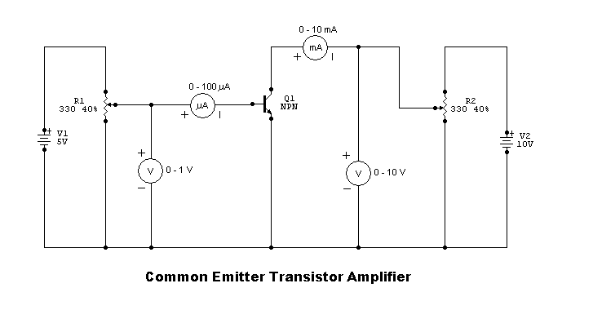

OBSERVATION TABLE
Input characteristics
VCE =0V |  | VCE = 3V |  | VCE =5V
VBE (V) | IB (mA) | VBE (V) | IB (mA) | VBE (V) | IB (mA)
0.5 | 2 | 0.5 | 0 | 0.5 | 0
0.6 | 15 | 0.6 | 4 | 0.6 | 2
0.64 | 25 | 0.64 | 8 | 0.64 | 9
0.68 | 35 | 0.68 | 15 | 0.68 | 16
0.7 | 39 | 0.7 | 19 | 0.7 | 20
0.74 | 53 | 0.74 | 28 | 0.74 | 32
0.78 | 63 | 0.78 | 42 | 0.78 | 40
0.8 | 69 | 0.8 | 46 | 0.8 | 48

Output characteristics
IB =10µA |  | IB =20µA |  | IB =30µA
VCE (V) | IC=(mA) | VCE (V) | Ic=(mA) | VCE (V) | Ic=(mA)
0.3 | 3.3 | 0.3 | 5.3 | 0.3 | 7.7
1 | 3.3 | 0.8 | 5.4 | 0.5 | 8
1.3 | 3.4 | 1.5 | 5.5 | 1 | 8.1
2.0 | 3.4 | 2.0 | 5.6 | 1.5 | 8.3
2.5 | 3.5 | 2.4 | 5.7 | 2.1 | 8.5
3.6 | 3.6 | 2.8 | 5.8 | 2.4 | 8.6
4.6 | 3.8 | 3.6 | 5.9 | 2.8 | 8.7
4.8 | 3.8 | 4.2 | 6 | 3.2 | 8.8
5.2 | 3.8 | 4.6 | 6.2 | 3.3 | 9
5.4 | 3.9 | 5.1 | 6.2 | 3.6 | 9.1
 |  | 5.4 | 6.4 | 3.8 | 9.1
 |  |  |  | 4.5 | 9.2

GRAPH
Input characteristic curve
CALCULATION
1)Dynamic output resistance(ro) = ∆VBE / ∆ IB keeping IB constant
EXPT NO : 8
DATE : 10.9.2008

RC PHASE SHIFT OSCILLATOR

AIM
To design,and set up an RC phase shift oscillator using BJT and to observe the sinusoidal output wave form on the CRO.

COMPONENTS REQUIRED

SL.NO | COMPONENTS | SPECIFICATION | QUANTITY
1  2  3  4  5  6  7 | Transistor  Resistor  Capacitor  DC power supply  CRO  Bread board  Wires | BC547  47k, 10k, 2.2k, 680k, 5k  4.7k  1µ, 2.2µ  .01µ  0-30 V  20 MHz,dual trace  -  - | 1  1  2  1  3  1  1  -

THEORETICAL BACKGROUND
If a common emitter amplifier is used,with a resistive collector load,there is a 180 degree phase shift between the voltages at base and collector.Feed back network between collector and base must introduce an adiitional 180 degree phase shift at a particular frequency.The required phase shift is the feedback from output to input obtained by using R and C components instead of the tank circuit.
Here a common emitter amplifier is followed by 3 sections of RC phase shift network,the output of the last section being returned to the input.In order to make the 3 RC sections identical,the third resistance is chosen as R-Ri where Ri is the input impedance of the circuit.The phase shift Φ,is given byeach RC section
Φ=tan⁻¹(1/RCω)
If R is made zero,then Φ will become 90 degrees.But making R=0,is impractical because if R=0,then the voltage across it will become zero.Therefore in practise the value of R is adjusted such that Φ becomes 60 degrres.
By analysis it can be expressed by the equation,
f=1/2пRC√6+4Rc/R
Condition for oscillation is given by the relation h_{fe}>23+29R/Rc+4Rc/R
While selecting the transistor,care must be taken to assure that its hfe is sufficently high .

DESIGN
Let Vcc = 12 V
Ic = 2 mA
β = 200

Vrc = 40 % of Vcc = 4.8 V
IcRc = Vrc = 4.8 V
Rc=4.8/(2*10^-3) = 2.4 kΩ
IeRe = 1.2 V
Re = (1.2*10^-3)/2 = 600Ω
Let Re = 680Ω
Vce = 50% of Vcc = (50*9)/100 = 4.5 V
Ic = β*Ib ie Ib = (2*10^-3)/200 = 10 µA
Current through Rc = 10 Ib
Current through R2 = 9 Ib
Vr2 = Vb+Vre = 0.6+1.2 = 1.8 V
R2 = 1.8/9 Ib = 10 kΩ
Let us take R2 = 10 kΩ
Vr1 = Vcc-Vr2 = 12-1.8 = 10.2 V
R1 = 10.2/10 Ib = 51kΩ
So let us take R1 = 47 kΩ
F = 1/(2*Π*R*C*sqrt(6))
Let C = 0.10 µF

CIRCUIT DIAGRAM

`
+
C
0.1uF
+
C1
0.1uF
+
C2
0.1uF
Vcc
BC 547
NPN
+
C3
22uF
+
C4
2.2uF
R4
R3
RE
680k
R2
18k
R1
82k
RC
2.2k
5k
47k
10k

PROCEDURE:
1.Set up the amplifier part of the oscillator
2.The power supply is switched on and Vcc is supplied
3.Connect the feed back network and observe the sine wave on the CRO and measure the amplitude and frequency of it.
4.Observe the waveforms at the base and collector of the transistor simulataneously on CRO screen and notice the phase difference between them.
5.The output waveforms are plotted to scale.

RESULT
The waveform for the RC Phase Shift Oscillator was obtained and observed.

CONCLUSION
The RC Network produce a 180 degree phase shift while the amplifier network produces the initial 180 degree phase shift. As a result the final feedback is positive and in phase. The waveform for the RC Phase shift Oscillator was obtained and observed.

